Practical No: 04
Aim:Login Automation and Validation Tool: Selenium WebDriver (Java/PHP) Write an automation script to perform login on a specified web page. Verify successful login using assertions such as URL validation, welcome message validation, and logout visibility check.
PRE-REQUISITES:
1) Check that you have JDK.
2) Check that you have Eclipse IDE.
3) Check that you have Selenium Server Driver and Client Driver(JAR files).
4) Check that you have Gecko Driver.
5) Check that you have a stable Internet connection.
STEPS:
1) Open Eclipse. Select your workspace directory. Click Launch:
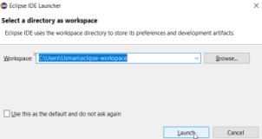
2) Create a Project(File > New > Java Project):
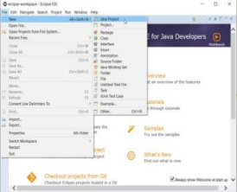
3) Name the project as “p7” > click Finish > click Don’t Create module:
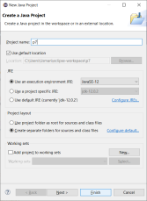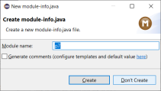
4) Close the “Welcome” tab.
5) Create a Package(right-click on Project Name > New > Package > Name it > Finish): 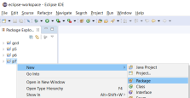 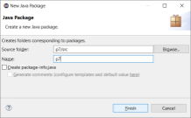6) Create a Class(right-click on Project Name > New > Class > Name it > Finish): 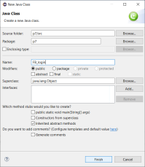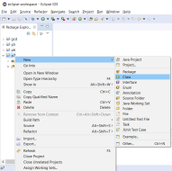7) Adding “Selenium Server Driver and Client Driver(JAR files)” in Eclipse IDE:
• right-click on Project Name > Build Path > Configure Build Path…
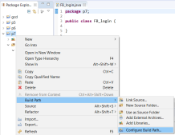
• now go under: Java Build Path > Libraries > Classpath > click Add External JARs 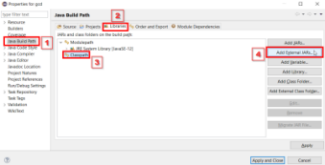• Browse and add JAR files > click Apply and Close :
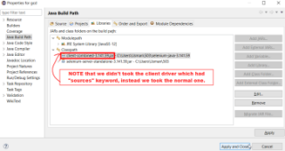8) Fetching ID’s of the HTML attributes of the elements from the facebook webpage. For instance we looking for the ID behind “Log In” button HTML element
(right-click over element(button/textbox) > click Inspect Element): (do the same for EMAIL TEXTBOX & PASSWORD TEXTBOX)
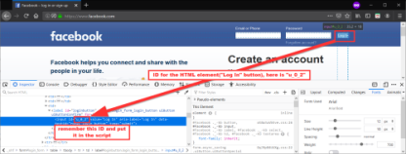9) Creating the script in JAVA:
• Now we’ll put the path of “geckodriver” in a String driverPath
• And in here, we’ll put the ID’s in the .id() method respectively.
---(FB_login.java)---
package p7;
import org.openqa.selenium.By;
import org.openqa.selenium.Keys;
import org.openqa.selenium.WebDriver;
import org.openqa.selenium.WebElement;
import org.openqa.selenium.firefox.FirefoxDriver;
import org.openqa.selenium.firefox.*;
import org.openqa.selenium.firefox.FirefoxOptions;
import org.openqa.selenium.firefox.FirefoxProfile;
import org.openqa.selenium.firefox.internal.ProfilesIni;
public class FB_login {
static String driverPath = "C:\\Users\\Usman\\503\\geckodriver.exe";
public static void main(String[] args) {
System.setProperty("webdriver.gecko.driver", driverPath);
//DesiredCapabilities capabilities = DesiredCapabilities.firefox(); //capabilities.setCapability("marionette",true);
ProfilesIni allProfiles = new ProfilesIni();
FirefoxProfile fp = new FirefoxProfile();
fp.setPreference(FirefoxProfile.PORT_PREFERENCE,"7055");
FirefoxOptions options = new FirefoxOptions();
options.setProfile(fp);

//objects and variables instantiation
WebDriver driver = new FirefoxDriver(options);
String appUrl = "https://www.facebook.com/";

//launch the firefox browser and open the application url
driver.get(appUrl);

//maximize the browser window
driver.manage().window().maximize();

//declare and initialize the variable to store the expected title of the webpage. String expectedTitle = "Facebook – log in or sign up";

//fetch the title of the web page and save it into a string variable String
actualTitle = driver.getTitle();

//compare the expected title of the page with the actual title of the page and print the result
if (expectedTitle.equals(actualTitle)) {
System.out.println("Verification Successful - The correct title is displayed on the web page.");
}
else {
System.out.println("Verification Failed - An incorrect title is displayed on the web page.");
}
//enter a valid username in the email textbox
WebElement username = driver.findElement(By.id("email"));
username.clear();
username.sendKeys("your email id");

//enter a valid password in the password textbox
WebElement password = driver.findElement(By.id("pass"));
password.clear();
password.sendKeys("your password");

password.sendKeys(Keys.ENTER);

//click on the Sign in button
WebElement LogInButton = driver.findElement(By.id("u_0_2"));
LogInButton.click();

//close the web browser
driver.close();
System.out.println("Test script executed successfully.");
//terminate the program
System.exit(0);
}
}
10) Run the file from Eclipse IDE:
• OUTPUT:
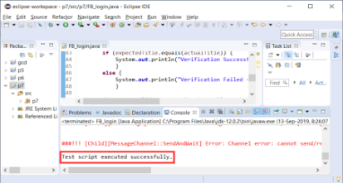11) Finish!

